Night vision 1

On a dark night a car is driving away from you.
You watch as its lights get dimmer and dimmer.
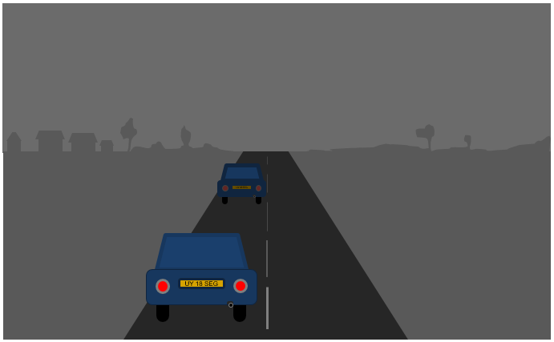

- Why do the lights get dimmer as the car drives away?
Put a tick (✓) in the box next to the best answer.
A | Light spreads out so less of it reaches your eyes
B | Light gets weaker as it travels
C | Your eyes can only see short distances in the dark
D | Light can only travel a short distance

Night vision 2

On a dark night a cyclist is coming towards you.
You watch as the light gets brighter and brighter.
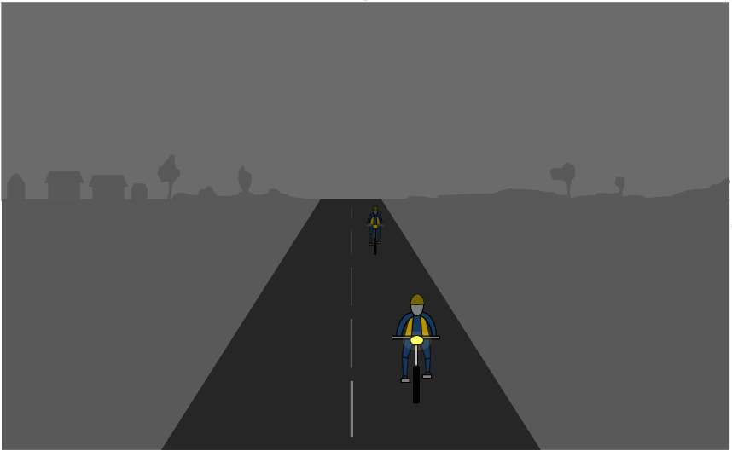

- Why does the light get brighter as the bike gets closer?
Put a tick (✓) in the box next to the best answer.
A | It is easier for the light to reach you
B | Light has spread out less so more of it reaches your eyes
C | There is less darkness to see through
D | The light has not travelled as far

Physics > Big idea PSL: Sound, light and waves > Topic PSL1: Sound and light > Key concept PSL1.2: Characteristics of light
Diagnostic question
Night vision

Overview
Learning focus: | Light travels in straight lines at very high speeds.
Observable learning outcome: | Explain why light gets dimmer farther from a light source.
Question type: | Simple multiple choice
Key words: | Light, travel, straight-line

What does the research say?
Stead and Osborne (1980) found that most students do not think of light travelling out very far from the source, particularly in day time. It has been found that about 40% of 13-15 year olds think that light travels different distances depending on whether it is night or day (Fethersonhough and Treagust, 1990).
This question checks what students understand about why a light source appears dimmer when it is farther away.
Ways to use this question
Students should complete the question individually. This could be a pencil and paper exercise, or you could use an electronic ‘voting system’ or mini white boards and the PowerPoint presentation.
The answers to the question will show you whether students understood the concept sufficiently well to apply it correctly.
If there is a range of answers, you may choose to respond through structured class discussion. Ask one student to explain why they gave the answer they did; ask another student to explain why they agree with them; ask another to explain why they disagree, and so on. This sort of discussion gives students the opportunity to explore their thinking and for you to really understand their learning needs.
Differentiation
You may choose to read the questions to the class, so that everyone can focus on the science. In some situations it may be more appropriate for a teaching assistant to read for one or two students.
Expected answers
1. A and 2. B
How to respond - what next?
The perceived brightness of a source changes with distance because light spreads out and less of it enters the eyes.
In question 1 students answering B imagine light as a substance that gets used up and answer D implies this thinking as well. With answer C, students may perceive darkness to be a material substance that smothers the light.
In question 2 answers A and C suggest students are thinking that darkness is a material substance and answer D that it is a substance that is used up as it travels.
If students have misunderstandings about the reason light gets dimmer with distance, it can help to use a torch beam to demonstrate the scientific model. Spraying a fine water mist can show clearly the width of a torch beam as it changes over distance and the light spreads out. Shining the torch onto a small target from different distances shows how brightness changes when the fraction of the torch beam hitting the target changes. Asking students to work in pairs or small groups to write a shared explanation of this can encourage social construction of the scientific idea through dialogue.
Acknowledgments
Developed by Peter Fairhurst (UYSEG), from York Science activity PLC1.3a by Mary Whitehouse (UYSEG).
Images: UYSEG
References
Fethersonhough, T. and Treagust, D. (1990). Students' understanding of light and its properties following a teaching strategy to engender conceptual change. Annual meeting of the American Educational Research Association. Boston.
Stead, B. F. and Osborne, R. J. (1980). Exploring students' concepts of light. The Australian Science Teachers' Journal, 26, 84-90.

